Order data sheet of broaches
Customer data | Company name |  |  |  |  |  |  | Contacts
Customer data | Address |  |  |  |  |  |  | Tel/E-mail
Workpiece data | Workpiece No. |  |  |  |  |  | Root radius
Workpiece data | □Mn □DP |  |  |  |  |  | Broaching length
Workpiece data | Number of tooth |  |  |  |  |  | Bore Dia. before broaching
Workpiece data | Pressure angle |  |  |  |  |  | finished Bore dia
Workpiece data | Outside Dia. |  |  |  |  |  | Material
Workpiece data | Root Dia. |  |  |  |  |  | Hardness |  |  | HB: HRC:
Workpiece data | M/dk
Workpiece data | profile |  |  | Ff |  |  | Fr |  |  | Fp
Workpiece data | Broaching machine |  |  | Rated pulling force |  |  | stroke |  |  | Machine model
Workpiece data | Amount of compensation of heat treatment deformation |  |  | Outside Dia. |  |  | Root Dia. |  |  | Keyway width
Workpiece data | Profile modifications |  |  | □Involute hz= Sz= |  |  | □Straight spline E= hz= Sz= |  |  | □Keyway E= H= D= hz= Sz=
Workpiece data |  |  |  | 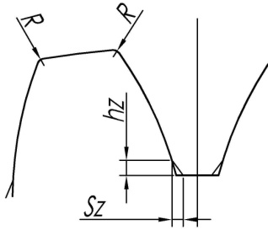 |  |  | 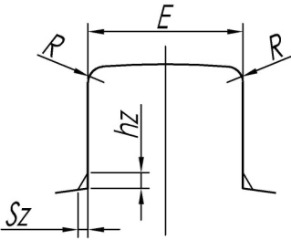 |  |  | 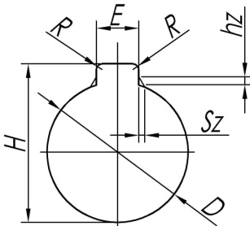
Data of broaches | Front end |  |  |  |  |  | Rear end
Data of broaches | Standard of reference |  |  |  |  |  | Standard of reference
Data of broaches | Size：L= L1= L2= L3= L4= D1= D1'= D2= e= C= |  |  |  |  |  | Size： L1= L2= L3= L4= D1= D2= C=
Data of broaches | 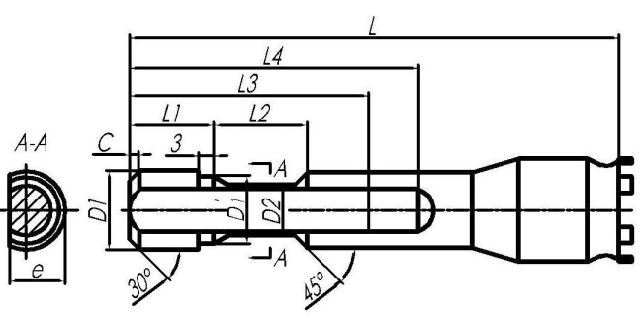 |  |  |  |  |  | 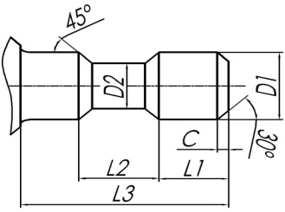  Cylindrical shape： |  |  | 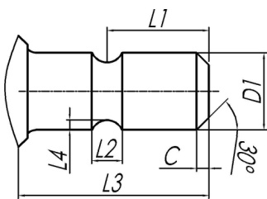  Rear bracket：
Data of broaches | Material |  |  | Coating |  |  | broaching length
Data of broaches | Marking
Note | Special structure needs to specified by the customer

